**APPLIED CRYPTOGRAPHY**

**LAB3**

**PSUEDO RANDOM NUMBER GENERATION**

NAME: VISHWAS M

SEC: F

SRN: PES2UG20CS390

DATE:27/09/2022

Task1:

Code:

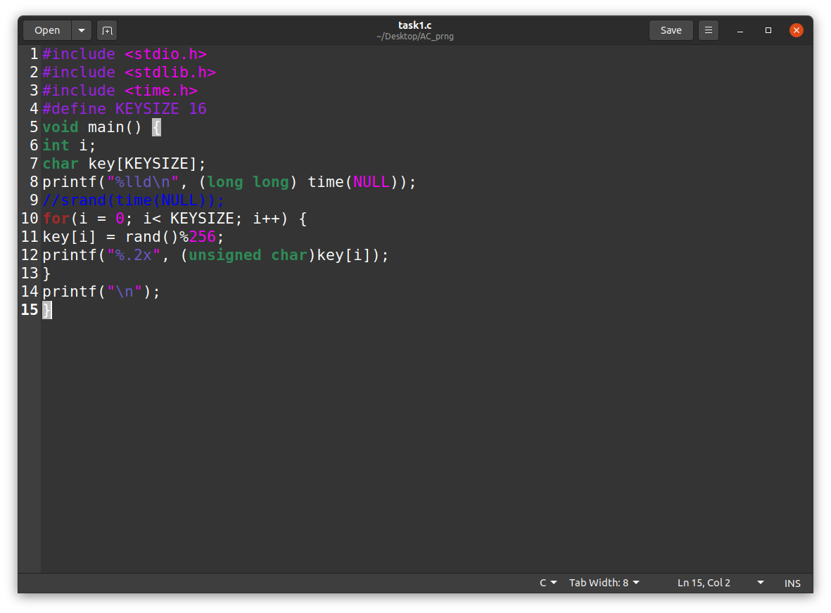

Step1 Output:

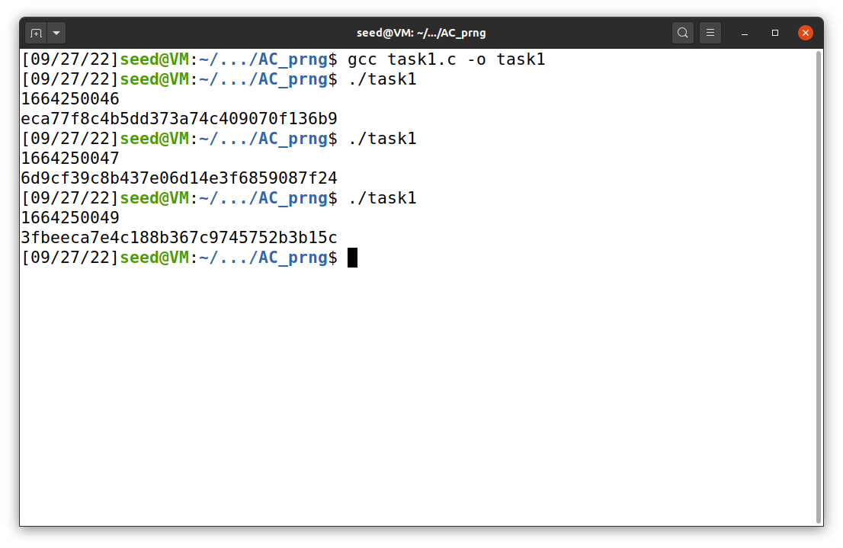

As we can see here the output varies whenever we execute the above code which means that each time it is generating different key values.

Step2 Output:

After commenting:

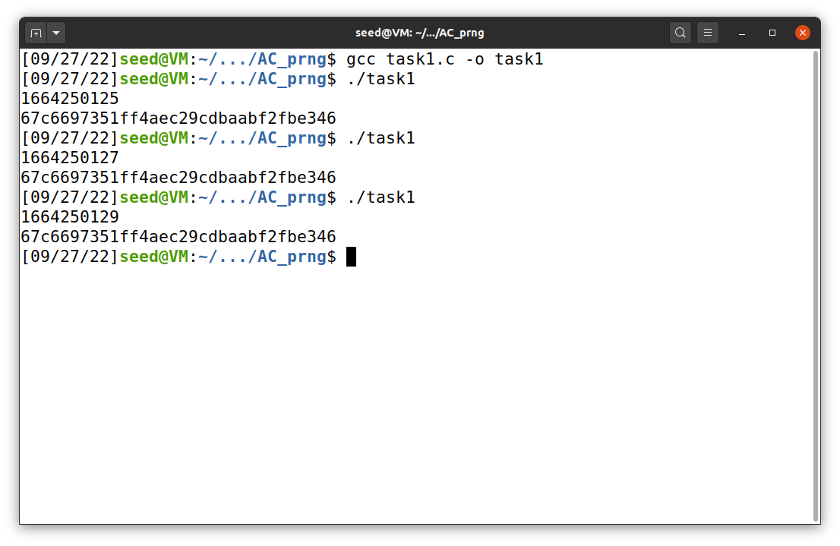

As we can see here the output varies whenever we execute the above code which means that each time it is generating same key values.

Task2:

Code:

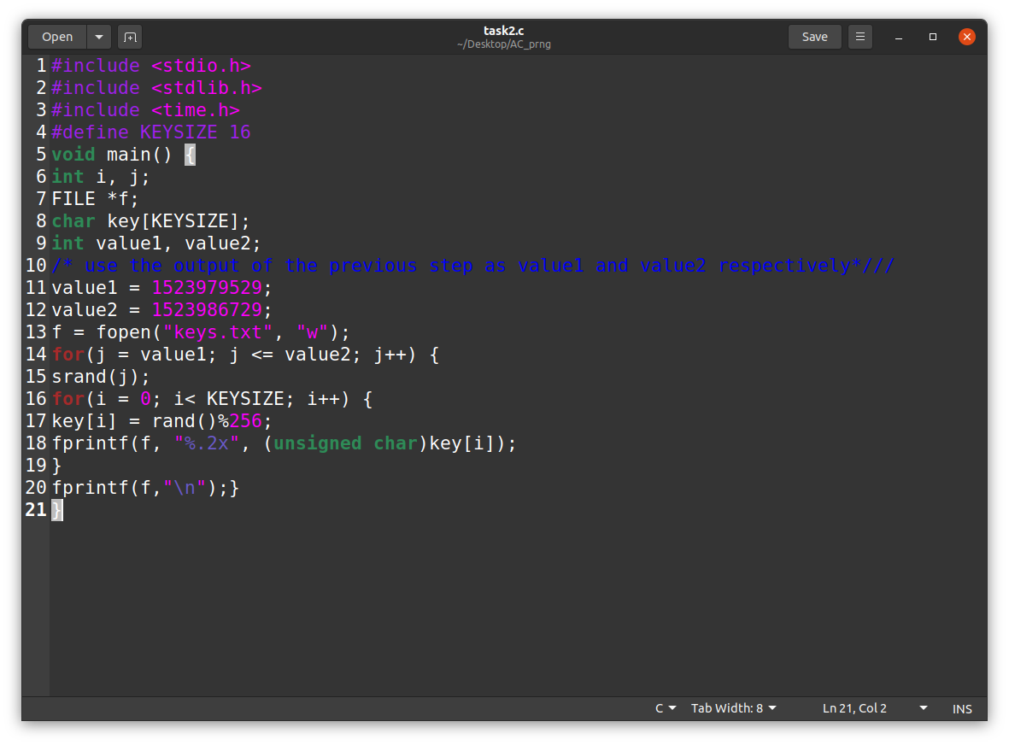

Step1 Output:

Output:

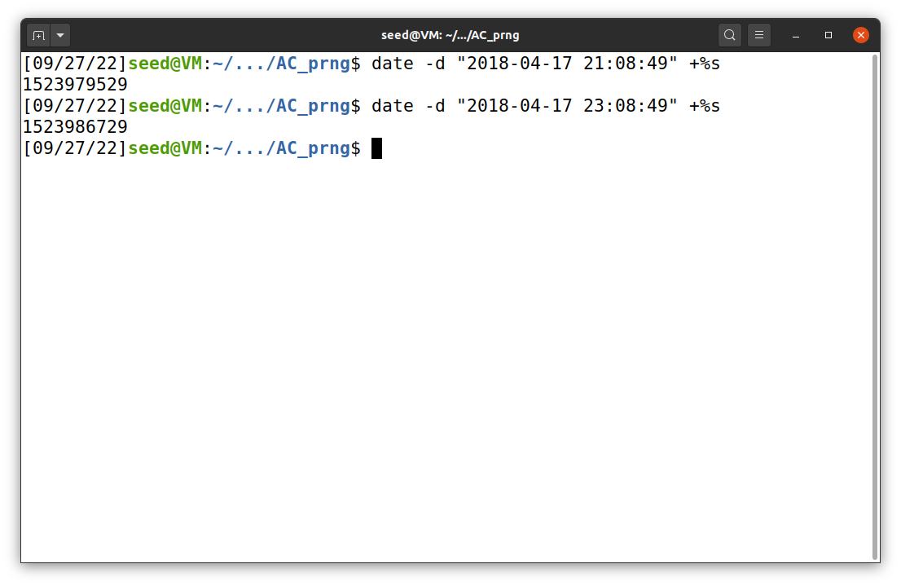

Step2 Output:

We are storing the output in a text file called keys.txt

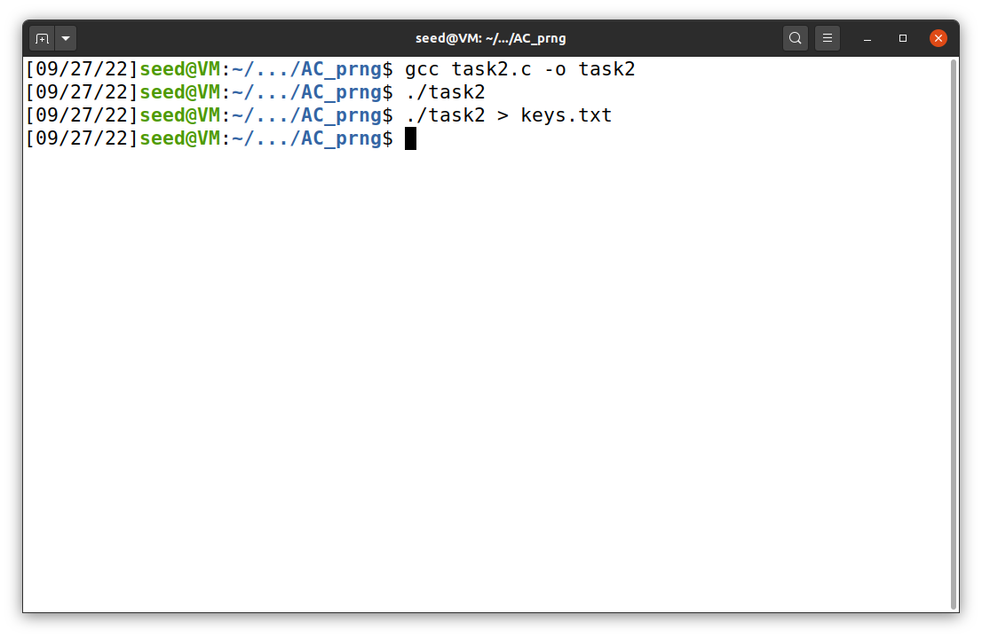

Keys generated in keys.txt:

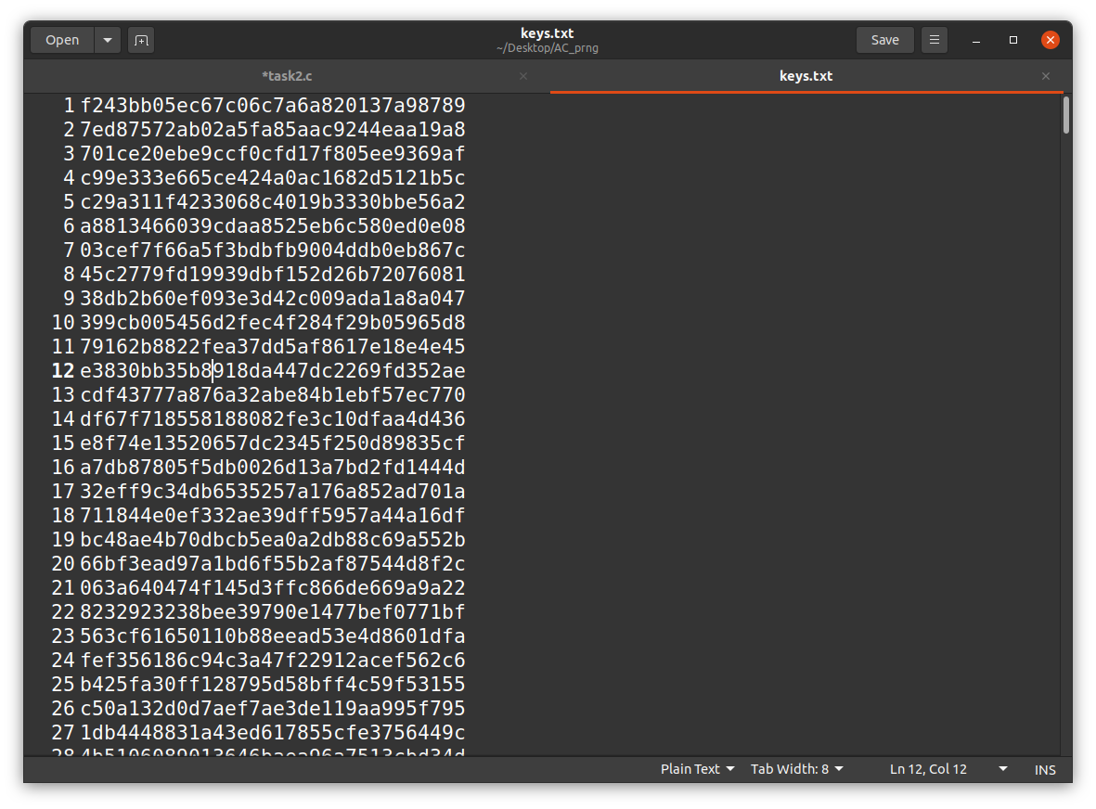

Step3 Output:

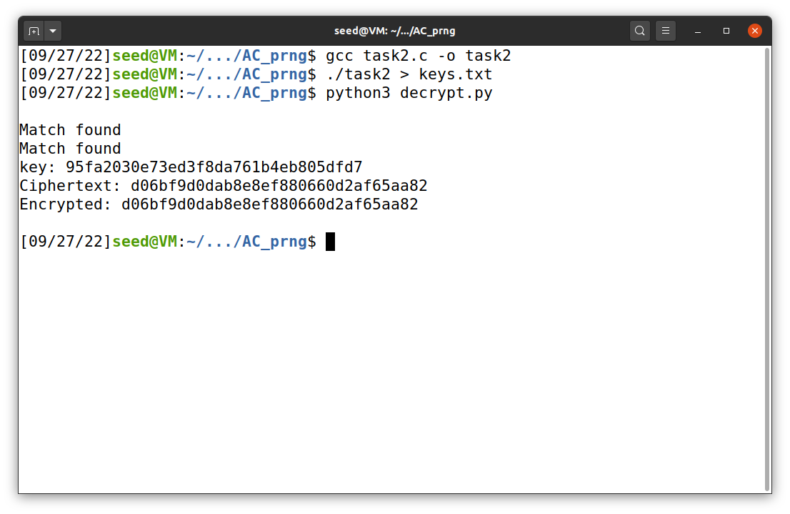

Task3:

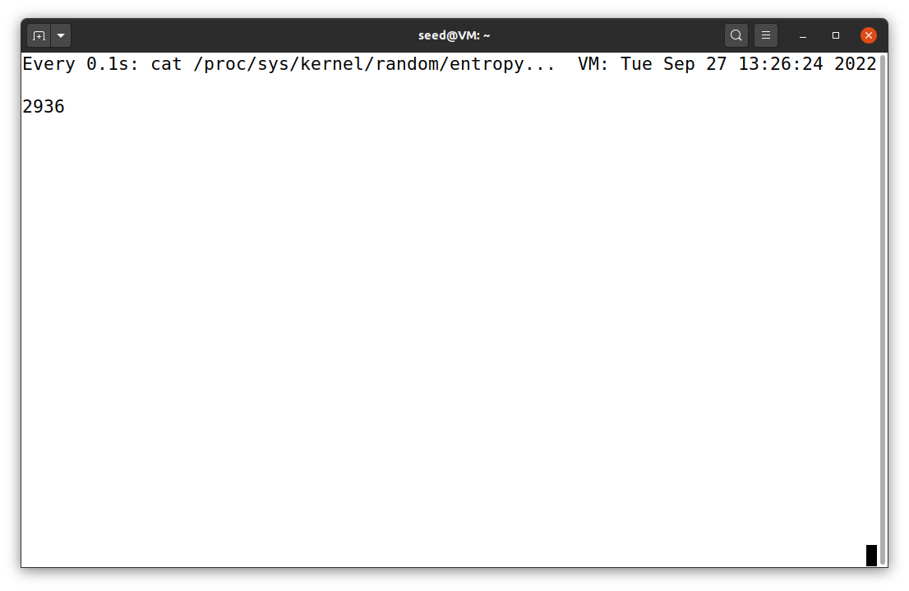

Task4:

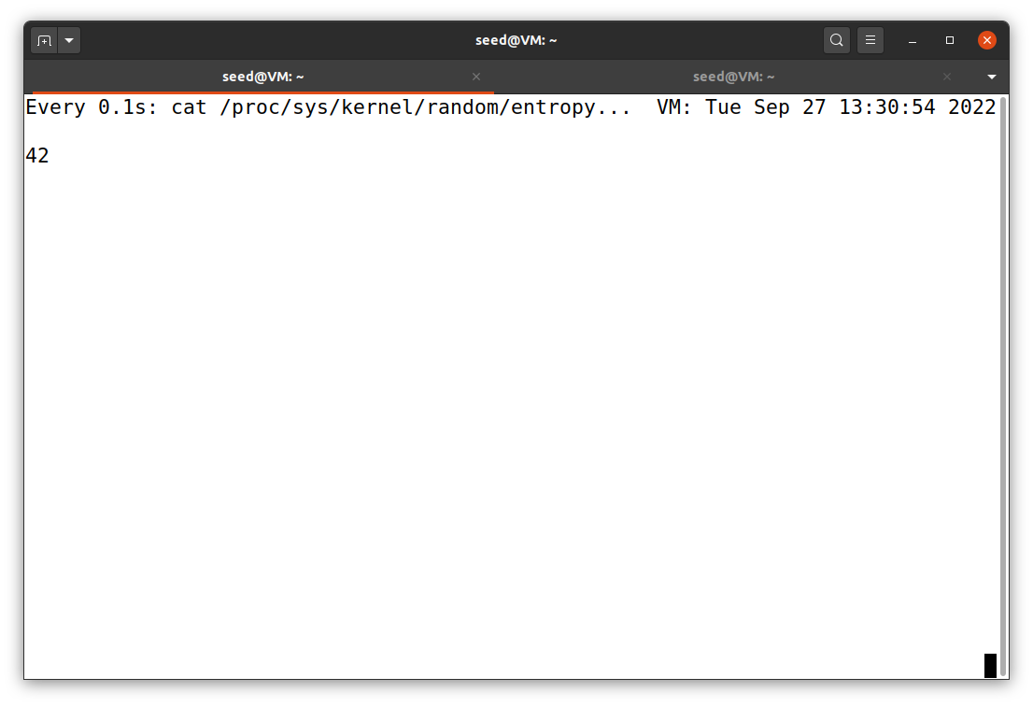

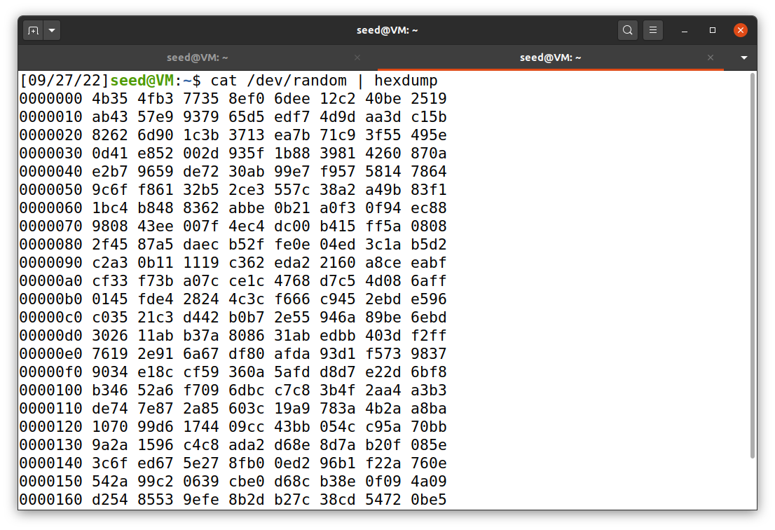

Task5:

Step1:

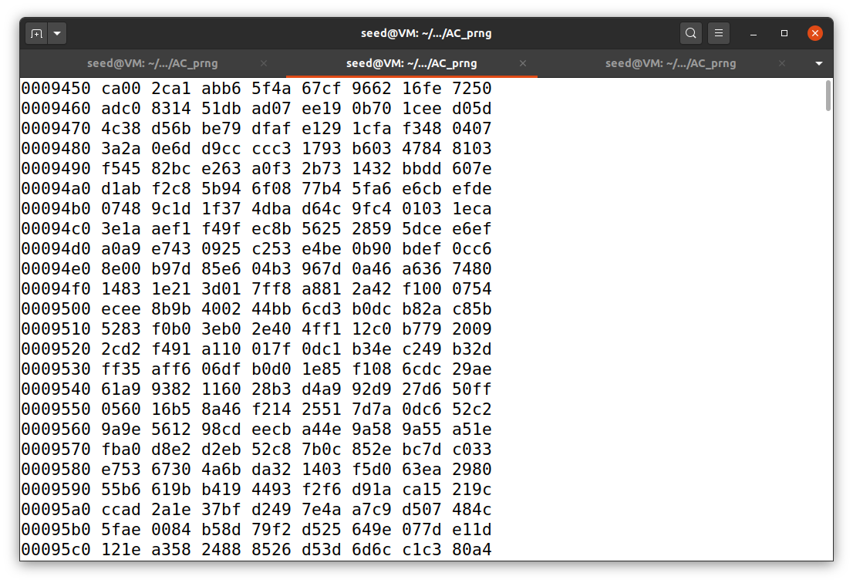

Step2:

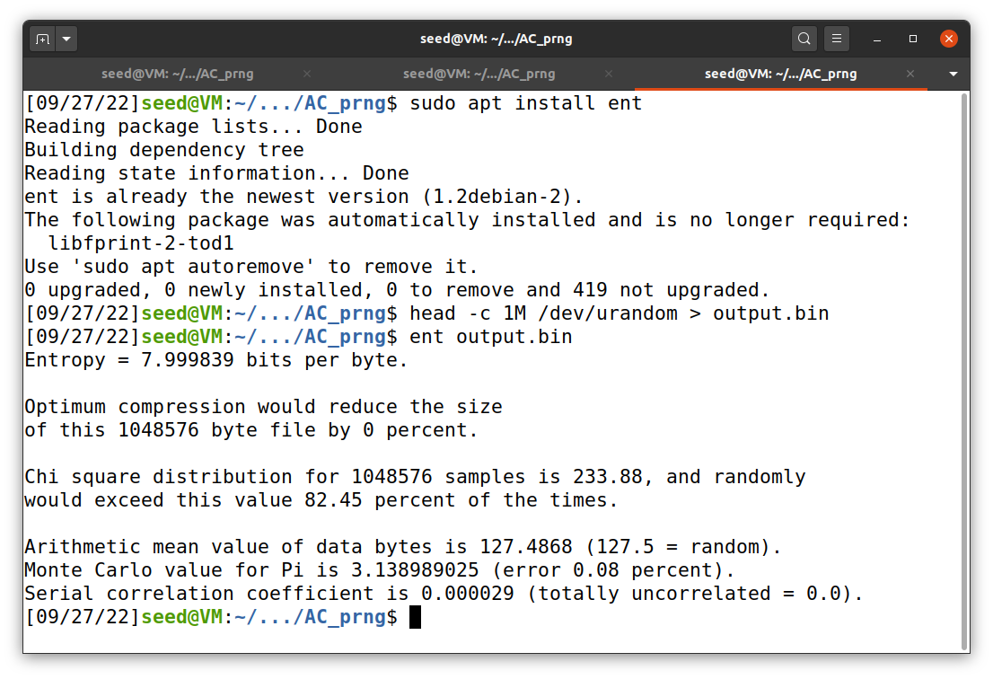

Step3:

Code:

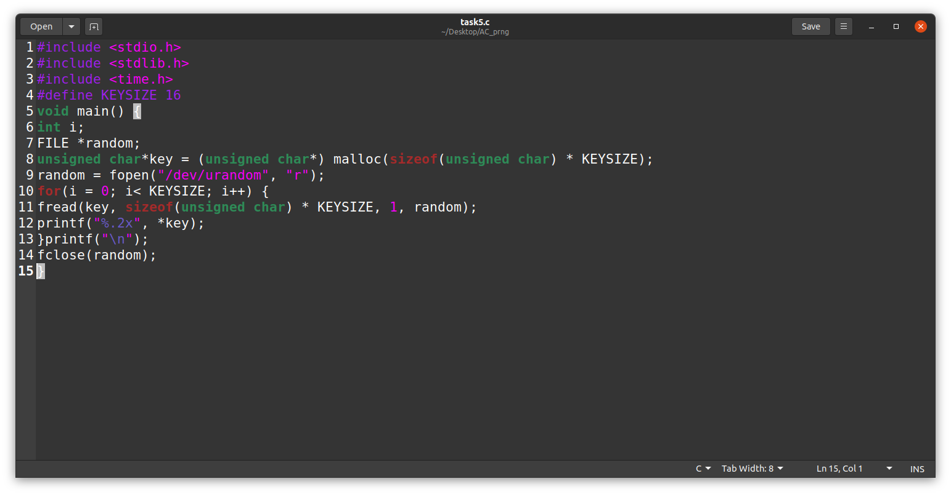

Output:

